# Calculating the Error

We used the test1.dps in estimating the error. As this test start the particles moves in the y direction due to the force of gravity so we focus in our analysis on the y direction (the same as the gravity force).

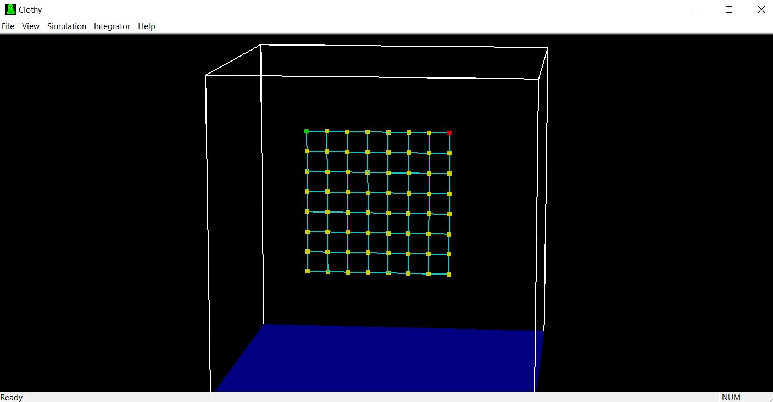

We pick our reference as the **RK 4th order** with **time step = 0.001**.

Our test samples of (time, Pos) is taken at **time step = 0.1**

We then draw the output of Each method against our reference **RK @ time Step=0.1** and w also calculate the absolute max error against the reference across all the samples that is taken at different times.

## Euler

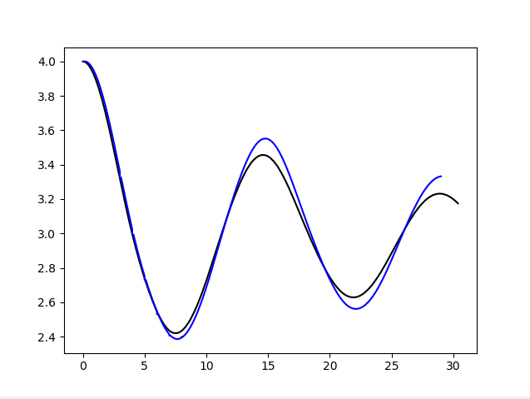 Max Error = 0.0435500000000002

## MidPoint

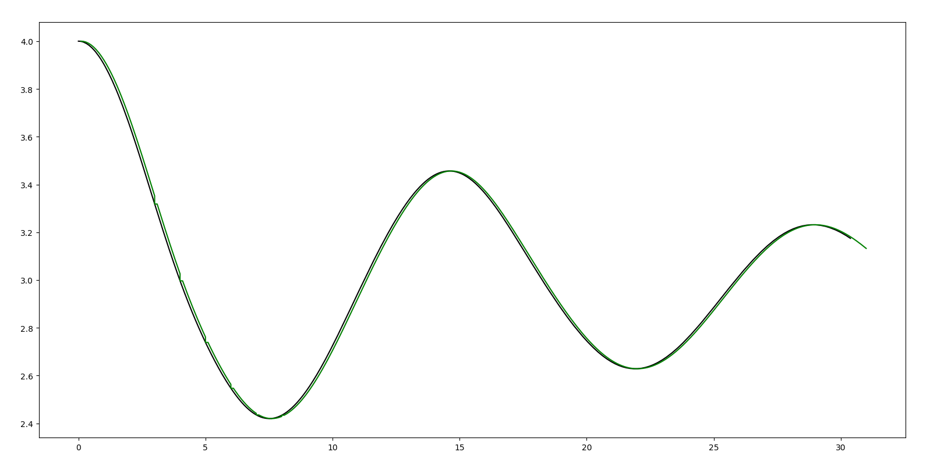

Max Error = 0.03406999999999982

## RK 4th Order

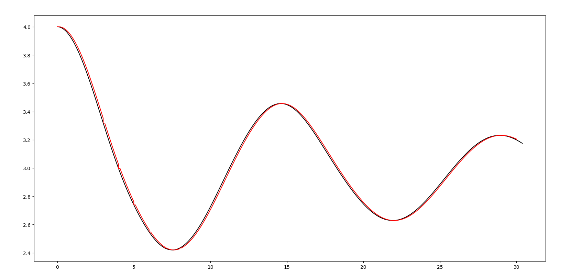

Max Error = 0.034259999999999735

## RK adaptive 4th Order

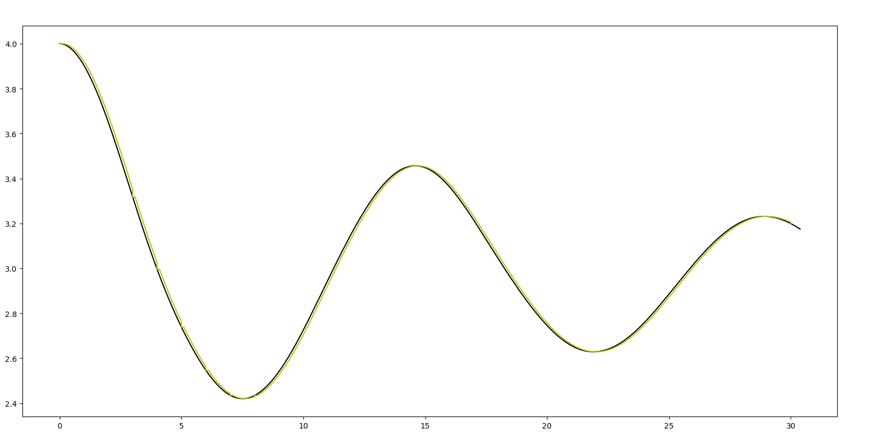

Max Error = 0.034259999999999735